Bwezani Mukuka
CS 340
February 22, 2026

Project Two: Grazioso Salvare Dashboard
This project involved building a fully functional client-server dashboard application for Grazioso Salvare, a non-profit providing specialized training of rescue animals. The goal of this project was to create a client-side dashboard using MongoDB to allow users to filter, view and compare data about shelter animals to find dogs best suited for particular types of rescues.
The dashboard will provide the following functionalities:
- Filtering interface with user options:
- Reset (All)
- Water Rescue
- Mountain / Wilderness Rescue
- Disaster / Tracking
- A data table that changes with each selection of the user to display only those dogs that meet the criteria of the selected rescue type.
- A bar Chart that graphically displays the top ten breeds from the data table for the current filtered data set.
- Map of Geolocations of the selected dog's location.
- Logo of Grazioso Salvare (branding).
The logic for filtering also restricts the consideration of only those dogs less than or equal to two (2) years of age (i.e., ≤ 104 weeks). Each of the rescue types also filters breeds according to the breed-specific criteria listed.
1. Filter by Reset 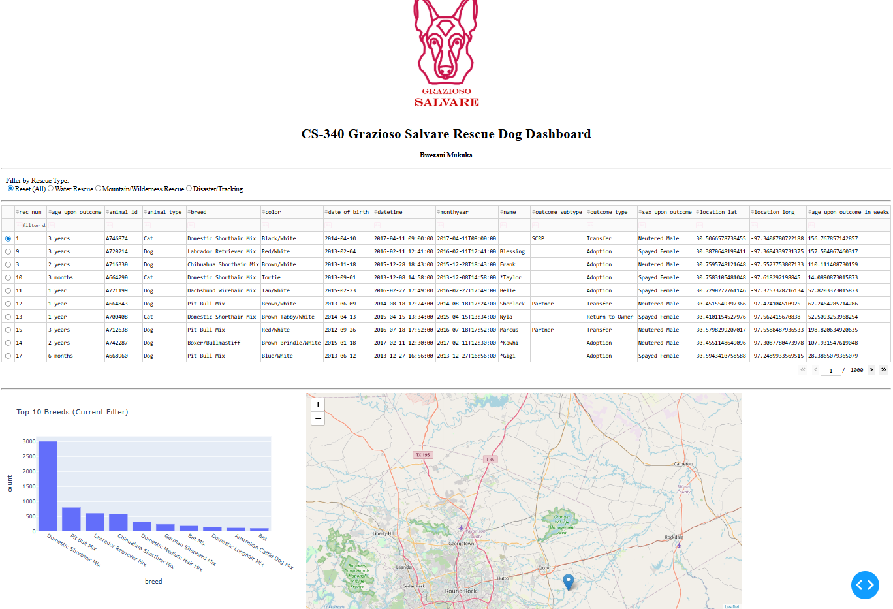
2.Filter by water rescue 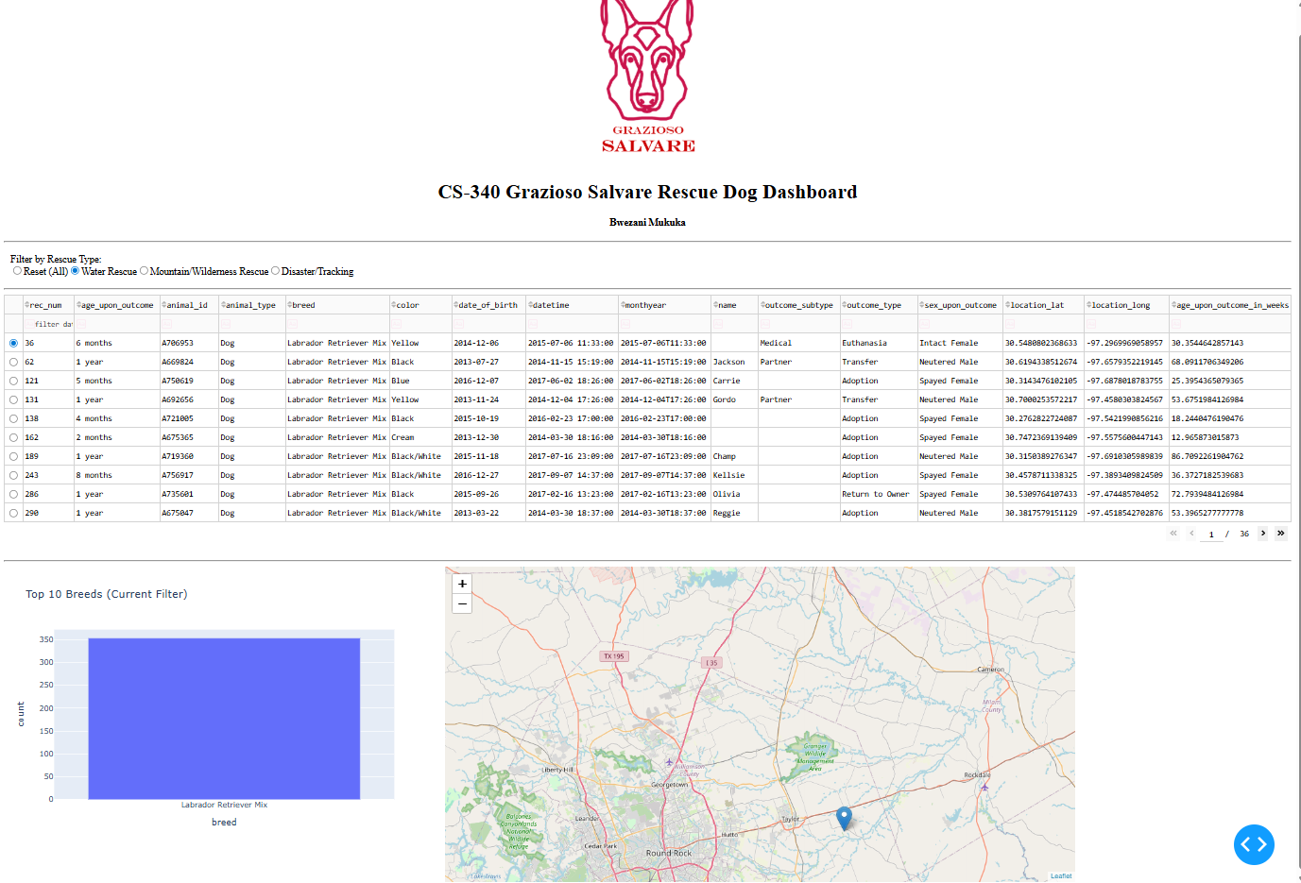
3. Filter by Mountain/Wilderness Rescue 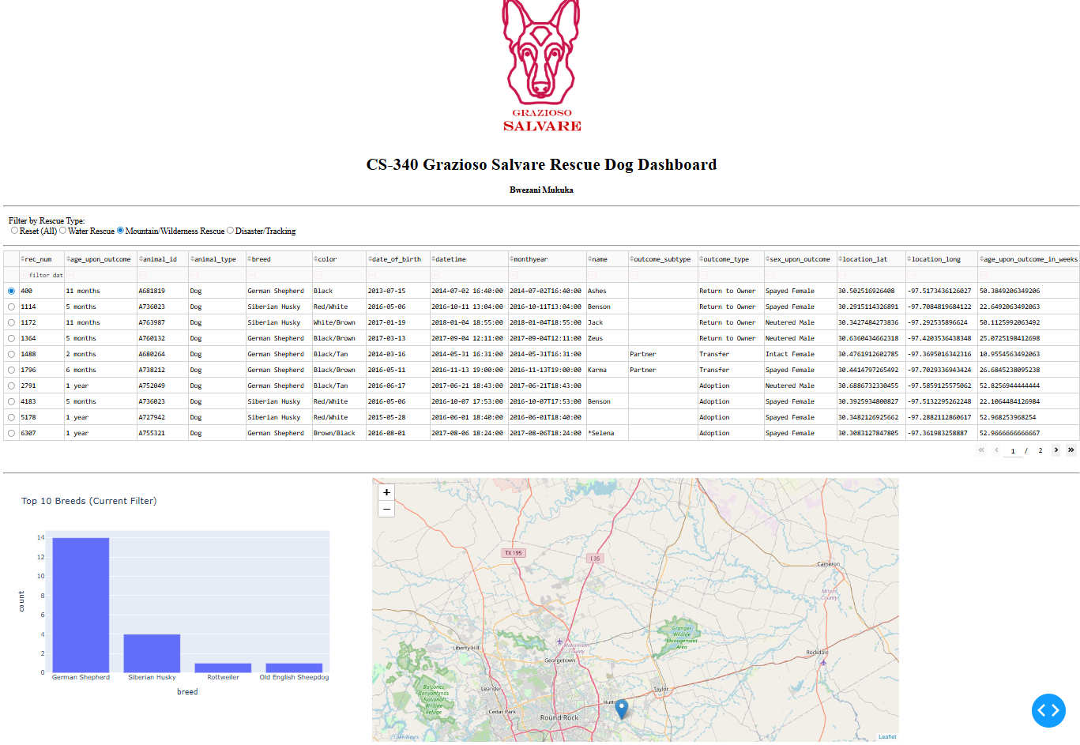
4.Filter by Disaster/Tracking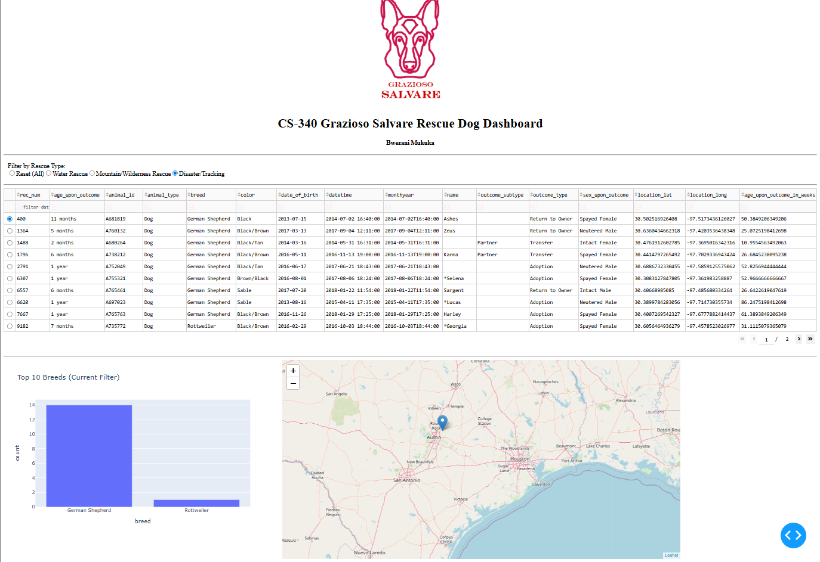

The screenshots above show the successful execution of the dashboard components.
Tools Used
Several tools were used to build this dashboard and ensure it works smoothly for users at Grazioso Salvare.
MongoDB was used to store the animal shelter data. It was chosen because it works well with Python and makes it easy to search and filter information. This allowed the dashboard to quickly find dogs that match specific rescue requirements, such as age and breed.
The CRUD Python module created in Project One was used to connect the dashboard to the database. Instead of placing database code directly inside the dashboard, the CRUD module keeps that logic separate and organized. This makes the project cleaner and easier to maintain.
The Dash framework was used to build the web dashboard. Dash allows interactive features, such as filter buttons and dynamic tables, to be created using Python. When a user selects a rescue type, Dash automatically updates the table, chart, and map without reloading the page.

Plotly Express was used to create the bar chart showing the most common breeds in the filtered results. Dash Leaflet was used to display the map and show the selected animal’s location. Pandas was used to organize and clean the data so it could be displayed properly in the table and charts.
Together, these tools made it possible to create a responsive, easy-to-use dashboard that connects the database to a clear and interactive visual interface.

Steps taken to complete the project
To complete this project, I first made sure that the MongoDB database created for Project One contained the correct data for the Austin Animal Center, and after confirming that the data was available, I used the previously created CRUD python modules to connect the dashboard to the database. Once the connection was established, I could have the dashboard use the retrieved information to display the animal records from MongoDB. Next, I created the initial layout of the dashboard by using the Dash framework. I included the Grazioso Salvare logo and my name to identify me uniquely within the dashboard. Next, I built an interactive data table, which would include all of the animal records in the database upon its initialization. For the user's convenience, I also gave them the ability to sort, filter and select one row at a time. In addition to building the interactive data table, I provided additional filters through the use of radio buttons. The radio buttons provided the user with the capability to choose between three categories of rescues (Water Rescue, Mountain/Wilderness Rescue, Disaster/Tracking) and four categories of dog characteristics (breed, age). As the user selects a category or characteristic, the dashboard will update the data table to only show the relevant animals. After completing the development of the filters, I created two additional visual elements for the dashboard: a bar chart displaying the top breed(s) represented in the current data table results, and a geolocation map showing the location of the currently selected animal. The bar chart and geolocation map were designed to dynamically update based on the user's selections within the filters and their interactions within the data table. Lastly, I tested each of the filters to verify that they functioned as expected by ensuring that both the data table and charts/maps updated accordingly when each filter was selected. Upon verification that all elements were functioning as required, I took screen shots to demonstrate the functionality of the dashboard.
Challenges that were encountered
During Development, I had to make multiple changes because of different problems that were occurring during my development process so that the Dashboard would work as expected.
A couple of the problems I had to deal with were with how to display data from Mongo DB into the dashboard Table. Mongo Db uses a unique identifier field (the _id) to identify each document in the database. The _id was causing the Table to fail whenever I tried to load the data into the Table. I solved this by stripping the _id from the documents before displaying the data to the users.
Another problem I had to deal with were the cases where there was no selection made from the User Input dropdowns/fields. The first time the user loads the dashboard, most of the fields/components will receive empty values, which caused errors. I solved these issues by adding simple checks for empty selections in those code sections.
I also ran into a problem where the Logo did not appear on the dashboard. This turned out to be caused by my incorrectly naming the logo file. Once I confirmed the correct name of the logo file, I updated the code to reflect this new file name. Through thoroughly testing each part/component of the dashboard and making specific changes, I verified that the dashboard was now working as intended and fulfilled all requirements.

